*Core Java - Interfaces Assignment*

**Instructions:**

Below you will find a series of assignments that you will complete in this exercise. You will need to create a new project folder for this task and name it **Java_Assignment_7_Interfaces**. You can use the default settings when creating the new project.

For each of the below assignments you will create new classes as specified below. You can keep them in the default package.

Most classes will NOT declare a main() method except for the Application.java file that you will write for a package. In your assignments, you will execute the main() method of the Application.java file.

**Assignments**

1. Create a package, “one” to place files in.

Write an interface **Movable** the declares a method move(). Create a class named Automobile that implements the move() method. In a main() method in an Application class, create a Movable object that is an instance of an Automobile. Execute the move() method.

1. Create a package, “two” to place files in.
2. Create an interface Animatable that extends Movable (from the above assignment) and declares a method animate(). Create a class named MoverAndAnimate that implements Animatable. In an Application2 class, create an instance of a MoverAndAnimate and execute both the move() and animate() methods.

**Goal:**

The purpose of this assignment is to provide you practice with writing classes that use interfaces. You will utilize the **main()** method of your classes to execute a particular goal of the assignment. This main() method should be implemented in a Application.java file.

By the end of this assignment, you will have 1 new project folder with the classes that meet the requirements mentioned above.

**Helpful Notes**

Project Structure:

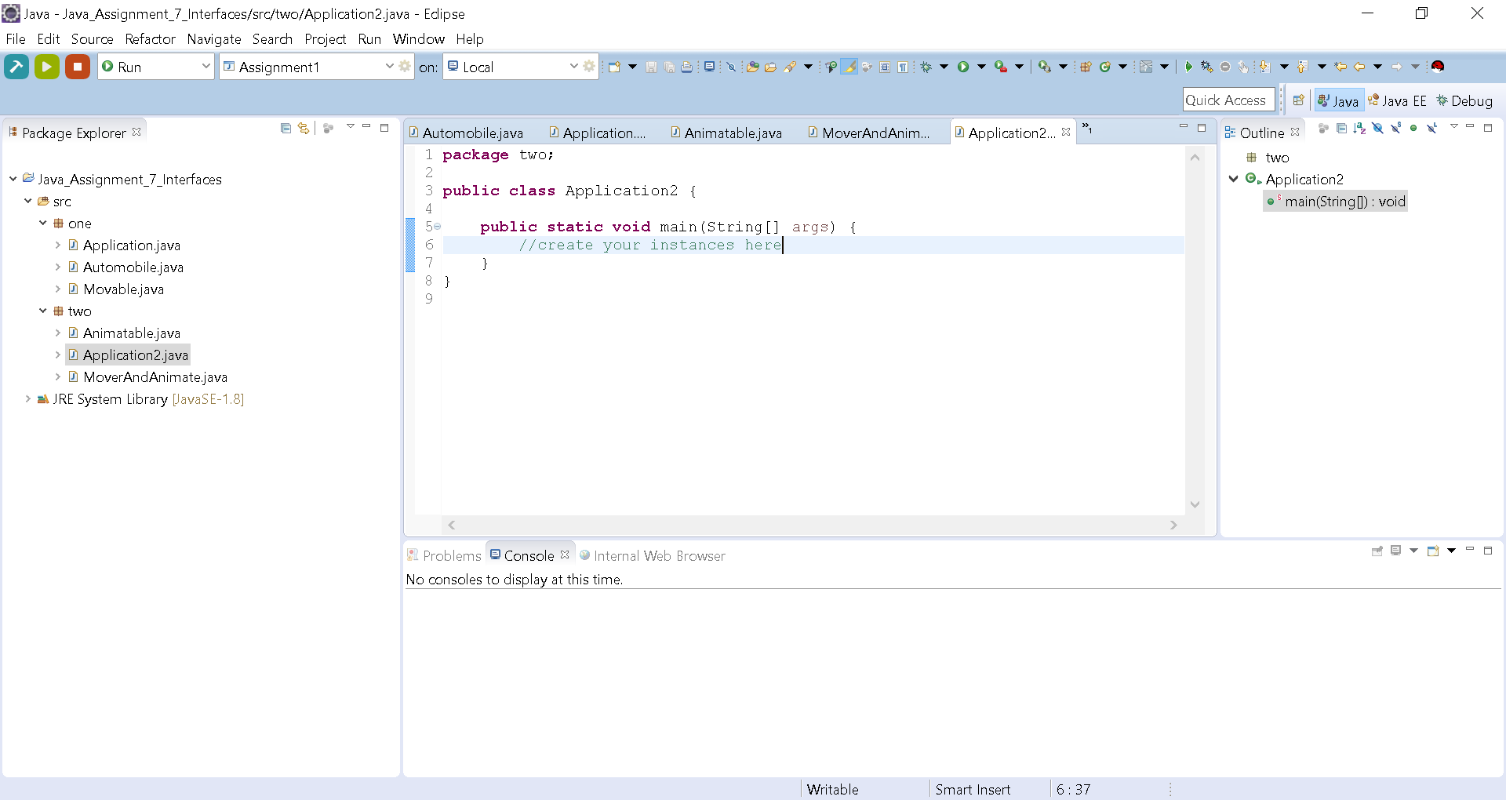

* Your project structure should resemble the above. Note that the name of the project is **Java_Assignment_7_Interfaces** and all class files are named according to the associated assigned number

Assignment Classes:

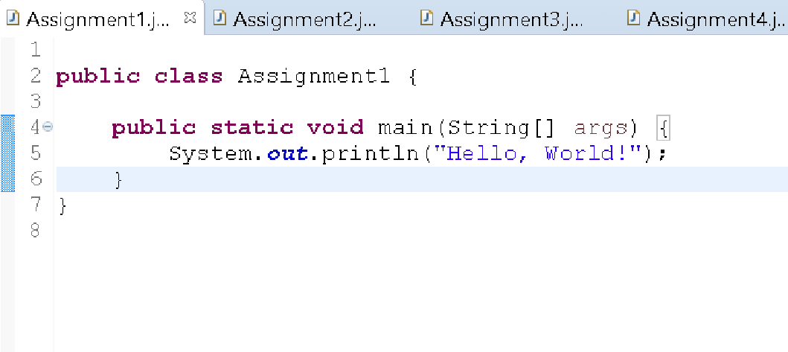

* Notice the indentation of the statement on line 5 to show that it is part of the main() method. Likewise, your code should follow this pattern.